MongoDB

* Open-source
* Document database
* NoSQL database
* Written in C++
* Cross platform
* **High performance, high availability and easy scalability**
* “Collection and document”
* Database – has collections – own set of files
* Server -> Database -> Collections -> MongoDB documents
* Collection is equivalent to **table** in RDBMS – no schema enforced
* Documents have different fields
* Documents in a collection have related purposes.
* Documents have **key-value** pairs
* Key-value pairs: two linked data items, key is **unique** identifier and value is either data or pointer to some other location; mostly for mapping purposes.
* Dynamic schema; That is documents in one collection need not have same set of fields; common fields across documents may be of different types

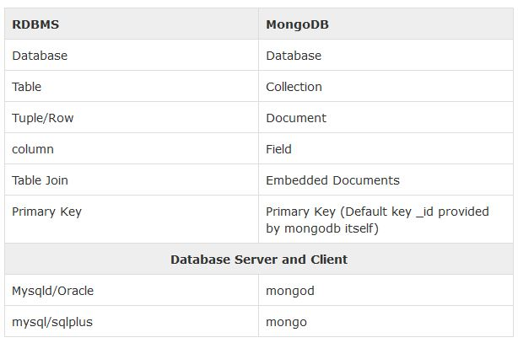

_id is a hexadecimal number for unique identification of document. - automatically generated

* No **relationship** concept
* Advantages
  + Less schema
  + No complex joins – embedded documents
  + Deep query ability – dynamic queries allowed
  + Faster access of data

Data Modeling